Sum of Odd Series

Aim
To find the sum of odd numbers up to a given limit using RAPTOR.

Apparatus Required
- Computer/Laptop
- RAPTOR Software
- Windows Operating System

Procedure
- Open RAPTOR.
- Input the limit.
- Initialize the sum as 0.
- Use a loop to add odd numbers.
- Update the sum.
- Display the final sum.
- Execute and verify the output.
Flowchart
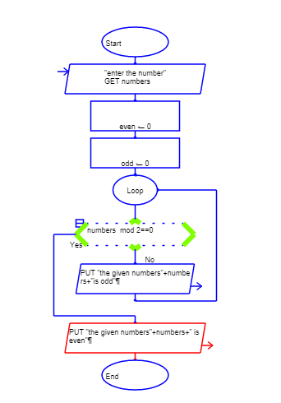

Input

Outpur


